Capstone Project Write-up: U.S. Organization (Option #1)
Fikru Korsa
MIS581: Capstone – Business Intelligence and Data Analytics
Colorado State University – Global Campus
Dr. Steve Chung
February 23, 2020

Capstone Project Write-up: U.S. Organization
In this assignment, I will be submitting a write-up for Capstone project. The components of this paper are abstract, research hypothesis, introduction, objectives, review of study, literature review, research design, findings, conclusions and recommendations.

Abstract
Food Safety and Inspection Service monitors all raw meat and poultry sold in interstate and foreign commerce, including imported products. It issues products recall when products are believed to be endangering public health and safety. In this paper, three hypotheses are tested by using FSIS-Recall-Summary dataset published by Food Safety and Inspection Service. The hypotheses assume products recall is not related to human error, periods of a year, and Salmonella. The hypotheses are tested by chi-square test using SAS. The finding indicates those reasons have association with products recall and rejected the null hypothesis.
Research Hypothesis
The following are the hypotheses for my project:
- Human error is not a reason for products recalls. The null hypothesis is that there is no relationship between products recall and human errors.
- Products recall is not related to seasons of a year. The null hypothesis here is there is no relationship between seasons of a year and product recall.
- Salmonella is not a significant reason for products recalls. The null hypothesis for this theory is that Salmonella is the reason that contributed the least to products recalls.
Introduction
Food Safety and Inspection Service (FSIS) is the public health regulatory agency responsible for ensuring that United States' commercial supply of meat, poultry, and egg products is safe, wholesome, and correctly labeled and packaged. The FSIS also acts as a national health department and is responsible for the safety of public food-related establishments as well as business investigation.
The research is for the completion of Capstone Project Write-up: U.S. Organization. The null hypotheses for each hypothesis listed above is accepted or rejected after testing hypotheses. This research is important to examine the association between product recalls by FSIS and human errors, the periods or seasons, and Salmonella as reasons for recalls. The dataset I selected my project is Summary of Recall Cases. This datasets summarizes and lists all the recalls of meat and poultry products produced by FSIS federally inspected establishments for the calendar year. Recalls are characterized by date, recall class, product, reason and pounds recalled (DATA.GOV, 2019).
Objectives
The objective of this research is analyzing the reasons for recalling food products by Food Safety and Inspection Service (FSIS). It analyzes the relationship between human errors, periods in a year, and Salmonella with products recall. FSIS inspects all raw meat and poultry sold in interstate and foreign commerce, including imported products (FEDERAL REGISTER). It inspects and monitor products and recalls them if the products are not safe for the public. This research uses data analytics tools to analyze the reasons FSIS mentioned. The analysis can help FSIS to identify how much impacts the selected reasons have on products and how to eliminate their effects. Another objective of this paper is also to show the Food Safety and Inspection Service how these tools can be used to analyze the recall summary dataset.
Overview of Study
This paper examines if there is a relationship between products recall and human error, time of a year, and Salmonella as reasons of recall. This study is important for FSIS to identify and evaluate the correlation products recall has with these reasons the strength or relationship, if any. The analysis conducted on FSIS Recall Summary public dataset to test created hypotheses and reject/accept null hypothesis. The findings are presented in the paper with screenshot of charts conducted using chi-square method in SAS. Conclusions and recommendations are the summarizing the paper and suggesting FSIS what actions can be taken in the future.
Literature Review
The mistakes employees make in a company lead to issues such as products recall. Mariam Matt (2017) mentioned that a mistake made by one or few employees led to the largest U.S. allergen recall by volume to date. The error led to milk inadvertently ending up in huge quantities of bread crumbs, which were then used in the making of packaged foods and distributed (Matti, 2017). This error was a cause for 3.7 million pounds of meat products.
Salmonella happens to be one of the reasons causing foodborne illness. USDA declared Salmonella as the most frequent reason reported for illness in its report published in 2018 (United States Department of Agriculture, 2018). Salmonella bacteria family includes over 2,300 stereo types.
Research Design
- Methodology
The paper is aiming at producing knowledge of a relationship between human errors, periods in a year, and Salmonella with products recall by Food Safety and Inspection Service. The type of data used for this analysis is quantitative data produced by FSIS in yearly FSIS Recall Summary data.
- Methods
The analysis method I used to test my hypothesis is chi-square test. By using SAS, all the hypotheses mentioned above are tested by chi-square method. I have created SAS code to test all three hypotheses using chi-square.
- Limitations
The dataset I chose for Capstone project, FSIS Recall Summary, is missing some of the variables that somehow affect the success of this analysis. Another limitation I would like to mention is time. As someone who is a full time employee and a father, I faced shortage of time to read the helpful resources that could have helped me complete this analysis in a better way.
- Ethical considerations
Ethical consideration is important while performing research and analysis. Ethical Considerations can be specified as one of the most important parts of the research (Research Methodology).
Findings
The first hypothesis I tested using chi-square is human error is not a reason for products recalls. The null hypothesis is that there is no relationship between products recall and human errors. As we can see, chi-square test result in screenshot below, there is an association between human error and products recall. Therefore, null hypothesis is rejected for this hypothesis. The null hypothesis is a characteristic arithmetic theory suggesting that no statistical relationship and significance exists in a set of given, single, observed variables between two sets of observed data and measured phenomena (Haldar, 2018).
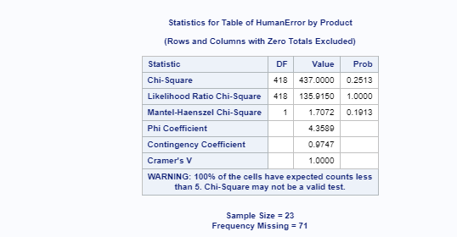
Fig.1. Analysis of Human Error by Product
The second hypotheses I tested in this assignment is Products recall is not related to seasons of a year. The null hypothesis here is there is no relationship between period of a year and product recall. Similarly, null hypothesis is rejected for hypothesis since there is a relationship between period of recall and products and pounds recalled, as indicated in below charts.
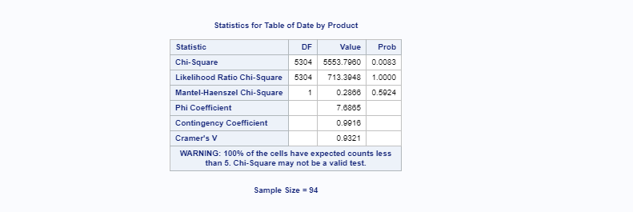
Fig.2. Analysis of Date of Recall by Products

Fig.3. Analysis of Date of Recall by Pounds
The third and final hypothesis I tested is Salmonella is not a significant reason for products recalls. The null hypothesis for this theory is that Salmonella is the reason that contributed the least to products recalls. Null hypothesis is rejected here as well.
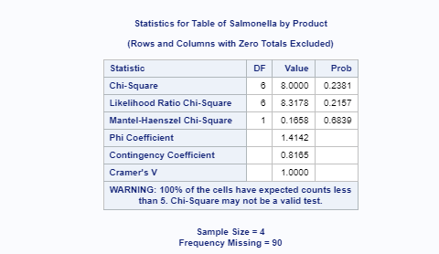
Fig.4. Analysis of Salmonella by Pounds
Conclusion
The research aims at producing knowledge of a relationship between human errors, periods in a year, and Salmonella with products recall by FSIS. The hypotheses created for this assignment assume these reasons have minimal to no relationship with products recall. After conducted the test using chi-square test method, the results indicate the reasons have relationship with the recall of products by FSIS and null hypotheses are rejected for all hypotheses.
Recommendation
Food Safety and Inspection Service recalls meat and poultry products to assure public health and safety. There are multiple reasons to issue recall on products. Those reasons are resulting from human error, technical issues, and others. The analyses in this assignment tested have proven that products recall have direct relationship with human errors, periods of a year, and Salmonella. I recommend Food Safety and Inspection Service pay close attention to these reasons during inspecting the products. The strategy will need to be developed as well to minimize and eliminate the effects of the reasons on products safety. I also recommend FSIS use analytics tools such as SAS to aid in determining whether and what additional precautions statistical analyses should be performed. The SAS System provides many different procedures to produce descriptive statistics, chi-square tests, and t-tests that assist decision-making roles.

References
DATA.GOV. (2019, May 2). FSIS - Summary of Recall Cases in Calendar Year. Retrieved from DATA CATALOG: https://catalog.data.gov/dataset
FEDERAL REGISTER. (n.d.). Food Safety and Inspection Service. Retrieved from federalregister.gov: https://www.federalregister.gov/agencies/food-safety-and-inspection-service
Haldar, S. K. (2018). Null Hypothesis. Retrieved from ScienceDirect: https://www.sciencedirect.com/topics/earth-and-planetary-sciences/null-hypothesis
Matti, M. (2017, June 14). Human Error Led to Recall of 4 Million Pounds of Food Due to Milk Allergen. Retrieved from Living Allergic: https://www.allergicliving.com/2017/06/14/human-error-led-to-recall-of-4-million-pounds-of-food-due-to-milk-allergen/
Research Methodology. (n.d.). Ethical Considerations. Retrieved from https://research-methodology.net/research-methodology/ethical-considerations/
United States Department of Agriculture. (2018, April 4). Retrieved from fsis.usda: https://www.fsis.usda.gov/wps/portal/fsis/topics/food-safety-education/get-answers/food-safety-fact-sheets/foodborne-illness-and-disease/salmonella/sa

SAS Codes for chi-square testing for each Hypothesis:

List of Hypotheses
- Human error is not a reason for products recalls. The null hypothesis is that there is no relationship between products recall and human errors.
Code:
proc freq data = Import;
tables HumanError*Product/ chisq;
run;

Screenshot:

- Products recall is not related to seasons of a year. The null hypothesis here is there is no relationship between seasons of a year and product recall.
Pounds recalled:
Code:
proc freq data = FSISRecallSummary;
tables Date*Pounds
/chisq
;
run;

Screenshot:

Products recalled:
Code:
proc freq data = FSISRecallSummary;
tables Date*Product/ chisq;
run;

Screenshot:

- Salmonella is not a significant reason for products recalls. The null hypothesis for this theory is that Salmonella is the reason that contributed the least to products recalls.
Code:
proc freq data = Import;
tables Salmonella*Product/ chisq;
run;

Screenshot:

Reference:
https://www.tutorialspoint.com/sas/sas_chi_square.htm

